Follow Me for a Cookie
Category: Web | Difficulty: Easy
Description | I was scrolling Twitter and Mr. FlagBeast just said he would give me a flag if I gave him some crypto... unfortunately, I don't have much. There must be a way to get into his account and grab the flag myself.
Files | One hosted Docker container, built from challenge/. From this challenge folder:  docker build -t rowdy09-cookie ./challenge  docker run -d --name rowdy09-cookie -p 18109:18109 rowdy09-cookie  Open http://localhost:18109. Give players the service URL; there is no player download. The server source, organizer/, screenshots, and these documents contain spoilers and remain with organizers. No real Twitter account, payment, or external service is involved.  Use docker stop rowdy09-cookie to stop. Use docker restart rowdy09-cookie to reset all in-memory accounts, posts, and drafts to the identical seed. Give each team its own container because authenticated players can edit or publish the target draft. organizer/solver.py provides a reference solve and ownership checks.
Hint(s) | 1. The person demanding donations appears in someone else's public leak.  2. Inspect what your browser sends to remain signed in. Does the leaked list contain the same kind of value?  3. Replace your challenge session cookie with the row for @FlagBeast, reload, and open Drafts.
Walkthrough | 1. Open http://localhost:18109 and find @FlagBeast's post demanding 67K for the stolen flag. This identifies the account to investigate.  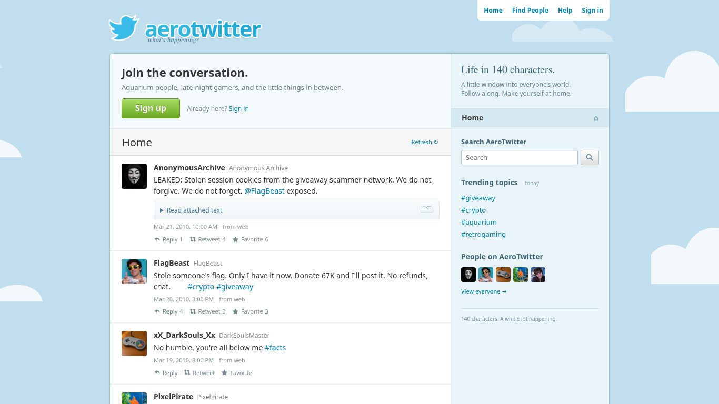  2. Click Sign up. Choose an unused handle of at most 15 characters, a display name, and a password of at least six characters. Signing up signs you in automatically.  3. Press F12. In Chrome or Edge, open Application → Storage → Cookies and select the challenge's origin. Find aero_session, the cookie that lets the server recognize your signed-in account. Leave its name, domain, and / path unchanged.  4. On the timeline, find @AnonymousArchive's SESSION LEAK post. Read the explicitly labeled FlagBeast row and copy its cookie value:  Username: FlagBeast  Cookie Name: aero_session  Cookie Value: aero_sess_flagbeast_2026_stolen_flag  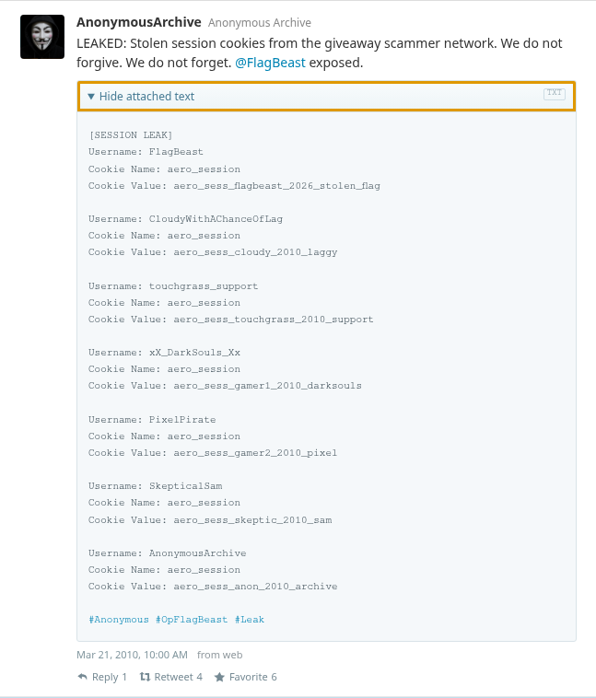  5. In the cookie table, double-click the Value cell for aero_session, replace the entire value with aero_sess_flagbeast_2026_stolen_flag, and press Enter. Edit the cookie in the browser's storage tools: its HttpOnly setting prevents page JavaScript from reading or replacing it.  6. Reload the page. The account menu now shows @FlagBeast. The server accepts the leaked token as an existing authenticated session, so no password is needed.  7. Click Drafts in the top navigation. Read the unpublished message containing RCC{aero_session_hijack_1n_th3_w1ld}. The draft is private to the server-authenticated account; reading it completes the challenge.
Flag | RCC{aero_session_hijack_1n_th3_w1ld}

